EXPERIMENT 3: PROBABILITY DISTRIBUTIONS AND BAYES’ THEOREM

1. Aim
To calculate covariance and correlation matrices, find eigenvalues and eigenvectors, and identify the principal directions of variation in hospital blood parameter data using NumPy, Pandas and Matplotlib.

2. Formulas
1. Bernoulli Distribution: P(X = x) = p^x (1 - p)^(1 - x)
2. Binomial Distribution: P(X = k) = C(n, k) × p^k × (1 - p)^(n - k)
3. Poisson Distribution: P(X = k) = (e^(-λ) × λ^k) / k!
4. Uniform Distribution: f(x) = 1 / (b - a), for a ≤ x ≤ b
5. Gaussian (Normal) Distribution: f(x) = [1 / (σ√(2π))] × e^[-(x - μ)^2 / (2σ²)]
6. Bayes' Theorem: P(Disease | Positive) = [P(Positive | Disease) × P(Disease)] / P(Positive)
7. Total Probability: P(Positive) = P(Positive | Disease) × P(Disease) + P(Positive | No Disease) × P(No Disease)
8. Posterior Probability: P(Disease | Positive) = (0.95 × 0.01) / [(0.95 × 0.01) + (0.10 × 0.99)]
9. Empirical Probability: P(Disease | Positive) = True Positive Count / Total Positive Test Count
10. Percentage: Percentage = Probability × 100
3. Overall Flow Diagram
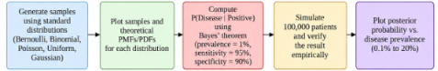

4. Code :

import numpy as np
import matplotlib.pyplot as plt
from scipy import stats
np.random.seed(42)
p = 0.3
bern = stats.bernoulli(p)
bern_sample = bern.rvs(size=1000)
x_bern = np.arange(0, 2)

n, p_bin = 10, 0.5
binom = stats.binom(n, p_bin)
binom_sample = binom.rvs(size=1000)
x_bin = np.arange(0, n + 1)

lam = 3
pois = stats.poisson(lam)
pois_sample = pois.rvs(size=1000)
x_pois = np.arange(0, 15)

a, b = 0, 1
uniform = stats.uniform(loc=a, scale=b-a)
uniform_sample = uniform.rvs(size=1000)
x_uniform = np.linspace(-0.2, 1.2, 300)

mu, sigma = 50, 10
normal = stats.norm(loc=mu, scale=sigma)
normal_sample = normal.rvs(size=1000)
x_normal = np.linspace(15, 85, 300)

# Plot distributions and theoretical PMFs/PDFs
fig, axes = plt.subplots(2, 3, figsize=(15, 9))

axes[0, 0].hist(
bern_sample, bins=np.arange(-0.5, 2, 1),
density=True, alpha=0.6, label="Sample"
)
axes[0, 0].plot(
x_bern, bern.pmf(x_bern), "ro-", label="PMF"
)
axes[0, 0].set_title("Bernoulli Distribution")
axes[0, 0].legend()

axes[0, 1].hist(
binom_sample, bins=np.arange(-0.5, 11.5, 1),
density=True, alpha=0.6, label="Sample"
)
axes[0, 1].plot(
x_bin, binom.pmf(x_bin), "ro-", label="PMF"
)
axes[0, 1].set_title("Binomial Distribution")
axes[0, 1].legend()

axes[0, 2].hist(
pois_sample, bins=np.arange(-0.5, 15.5, 1),
density=True, alpha=0.6, label="Sample"
)
axes[0, 2].plot(
x_pois, pois.pmf(x_pois), "ro-", label="PMF"
)
axes[0, 2].set_title("Poisson Distribution")
axes[0, 2].legend()

axes[1, 0].hist(
uniform_sample, bins=20, density=True,
alpha=0.6, label="Sample"
)
axes[1, 0].plot(
x_uniform, uniform.pdf(x_uniform),
"r-", label="PDF"
)
axes[1, 0].set_title("Uniform Distribution")
axes[1, 0].legend()

axes[1, 1].hist(
normal_sample, bins=25, density=True,
alpha=0.6, label="Sample"
)
axes[1, 1].plot(
x_normal, normal.pdf(x_normal),
"r-", label="PDF"
)
axes[1, 1].set_title("Gaussian Distribution")
axes[1, 1].legend()

prevalence = 0.01
sensitivity = 0.95
specificity = 0.90
false_positive_rate = 1 - specificity

posterior = (
sensitivity * prevalence
/ (sensitivity * prevalence
+ false_positive_rate * (1 - prevalence))
)
print("Bayes' Theorem Result:")
print(f"P(Disease | Positive) = {posterior:.4f}")
print(f"Posterior Percentage = {posterior * 100:.2f}%")

N = 100_000

disease = np.random.random(N) < prevalence
test_positive = np.where(
disease,
np.random.random(N) < sensitivity,
np.random.random(N) < false_positive_rate
)

positive_count = np.sum(test_positive)
true_positive_count = np.sum(disease & test_positive)

empirical = true_positive_count / positive_count

print("\nSimulation Results:")
print("Total Patients:", N)
print("Positive Tests:", positive_count)
print("True Positive Cases:", true_positive_count)
print(f"Empirical Posterior = {empirical:.4f}")
print(f"Empirical Percentage = {empirical * 100:.2f}%")

prevalences = np.linspace(0.001, 0.20, 200)

posteriors = (
sensitivity * prevalences
/ (sensitivity * prevalences
+ false_positive_rate * (1 - prevalences))
)

axes[1, 2].plot(
prevalences * 100, posteriors * 100, "b-"
)
axes[1, 2].set_title("Posterior vs Prevalence")
axes[1, 2].set_xlabel("Disease Prevalence (%)")
axes[1, 2].set_ylabel("P(Disease | Positive) (%)")
axes[1, 2].grid(True)

for ax in axes.flat:
if ax != axes[1, 2]:
ax.set_xlabel("Value")
ax.set_ylabel("Probability / Density")
ax.grid(alpha=0.2)

plt.tight_layout()
plt.show()

5. Output
Bayes' Theorem Result:
P(Disease | Positive) = 0.0876
Posterior Percentage = 8.76%
Simulation Results:
Total Patients: 100000
Positive Tests: 10899
True Positive Cases: 960
Empirical Posterior = 0.0881
Empirical Percentage = 8.81%

Graph
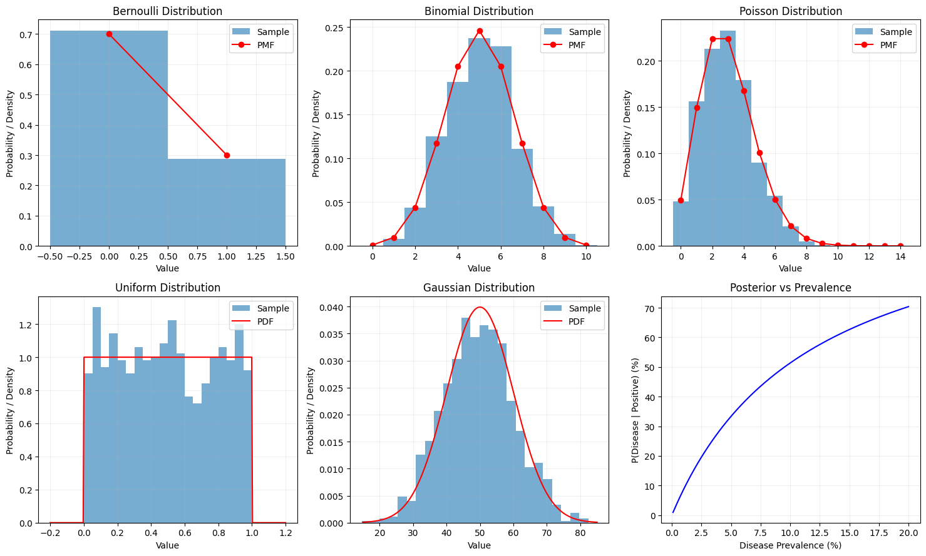

6. Result
The five probability distributions were generated and visualized successfully using SciPy, NumPy, and Matplotlib. Bayes’ theorem was applied to calculate the probability that a patient with a positive test result actually has the disease. For a disease prevalence of 1%, sensitivity of 95%, and specificity of 90%, the theoretical posterior probability was found to be 8.76%. A simulation of 100,000 patients was performed to verify the result empirically. The posterior probability graph showed that the probability of disease after a positive test increases as disease prevalence increases from 0.1% to 20%.

